**Our Energy Future**

**Wind Power and Turbine Technologies**

The US government established an objective of 25% electricity from wind by 2025, requiring a 12x increase in capacity. To meet that capacity, leading-edge wind energy R&D is necessary to achieve that goal.

Part of this R&D includes advanced simulation of how turbines will perform in the field. There are numerous variables at play that effect turbine performance – aerodynamics of the turbine, wave behavior (in the case where the turbine is located on water), as examples – and these simulations would be able to predict failure due to external loads, evaluate design, and optimize aerodynamics of the turbine. One of the largest opportunities for advancement of performance is the rotor assembly.

There are two types of wind turbines – horizontal-axis and vertical axis (HAWTs and VAWTs, respectively). Horizontal axis turbines are more popular and probably what you picture when you think of wind turbines. The horizontal axes isn’t exactly horizontal, it tilts up 4-5 degrees so to avoid the blade striking the tower with strong winds at the bottom of its rotation. Vertical axis turbines are gaining popularity in confined locations like urban areas because of their compact design.

*How does a turbine work?*

First things first, turbines are based on the inflow of wind, which creates pressure on the rotor and blades which in turn creates torque around the main axis. As the rotor/blades spin, the main shaft and gearbox consequently spins along with it. This causes the generator to spin, resulting in electrical output.

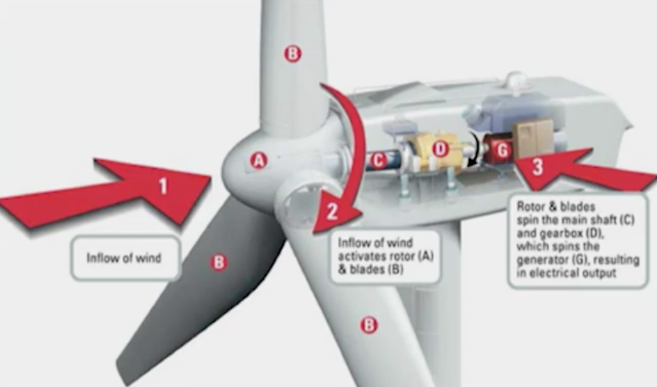

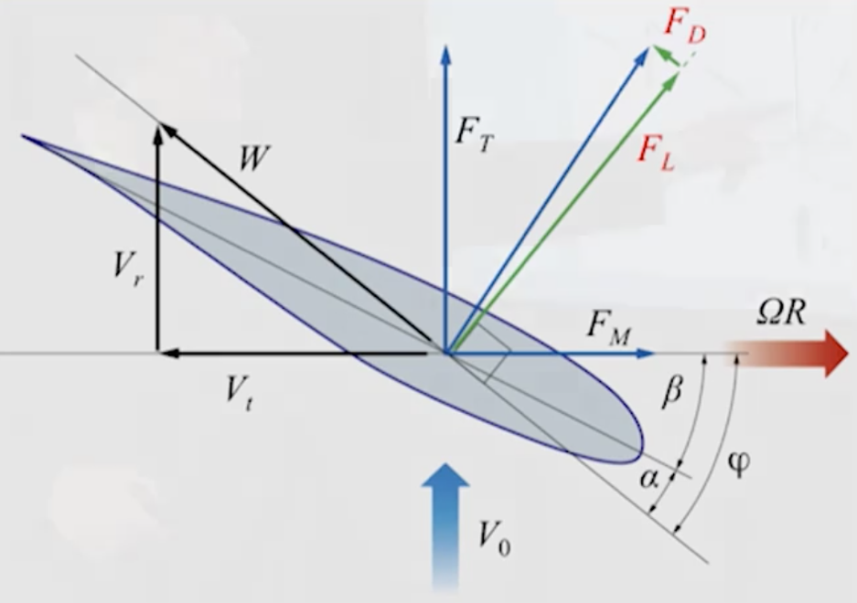*How do the aerodynamics work?*

As incoming wind hits the leading edge (called the *pressure side*, represented by the blue arrow in the diagram) of the airfoil, the flow accelerates around the blade toward the back, corresponding with a tremendous drop in pressure, called *negative suction pressure* resulting in a *lift vector* (marked by FL in the diagram).

What you want to do is design the turbine so your lift vectory has a component in the direction of rotation (marked as FM in the diagram).

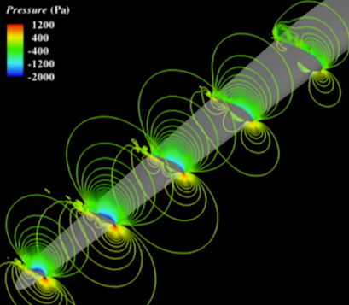This distribution of the pressure is illustrated below. Notice that the pressure goes from 400-1200 at the front of the blade (yellow/green), to -400 to -2000 in the back.

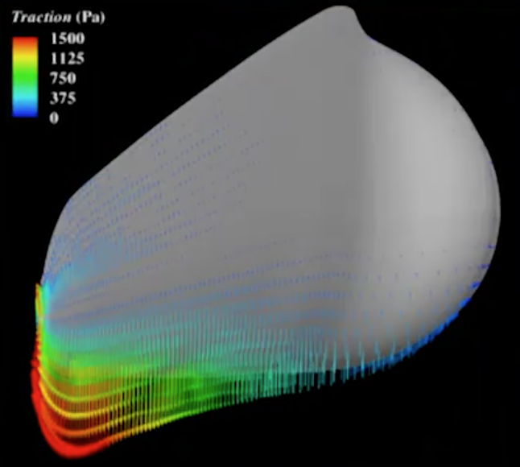Looking at the turbine at the cross-section of the turbine, you see the majority of the pressure is located at the tip of the turbine. In order to achieve efficiency gains in the aerodynamics of the turbine, the changes would need to occur on the tip of the turbine. The bulbous, nearly circular portion of the turbine at the root of the cross-section is designed that way because of the structural mechanics challenges, not because of the aerodynamics challenges.

Ideally, as the wind speed increases, the *torque* increases along with it. Torque is a measure of how much a force acting on an object causes that object to rotate, and is most commonly measured in the units *newton metrics* (abbreviated as ). Combine the torque with the rotational speed of the turbine, you can arrive at the amount of energy that is being produced by that turbine at the given speed.

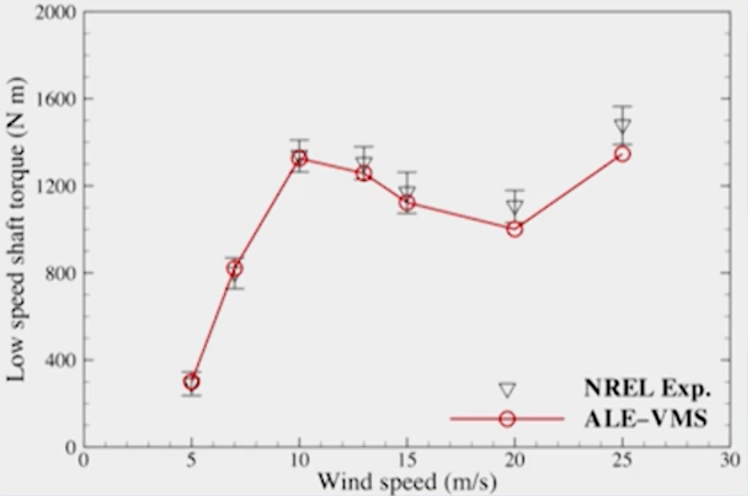However, the torque does not necessarily increase as wind speed increases; that is dependent on the design of the turbine and its aerodynamics. The graph shows that the aerodynamics of this particular turbine causes resistance at wind speeds between ~10 m/s and ~20 m/s.

Different turbines have different features, the important ones being:

* *Radial distance*: how long the turbine is the
* *Airfoil type*: whether the cross-section of the turbine is cylindrical or some other shape
* *Chord length*: how wide the cross-section of the turbine is
* *Twist angle:* the angle of the blade’s cross-section

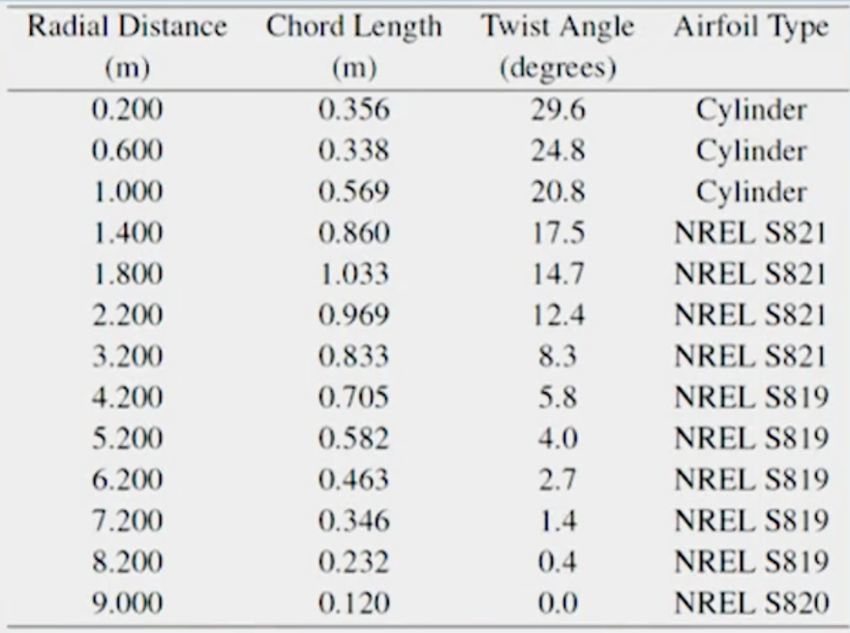

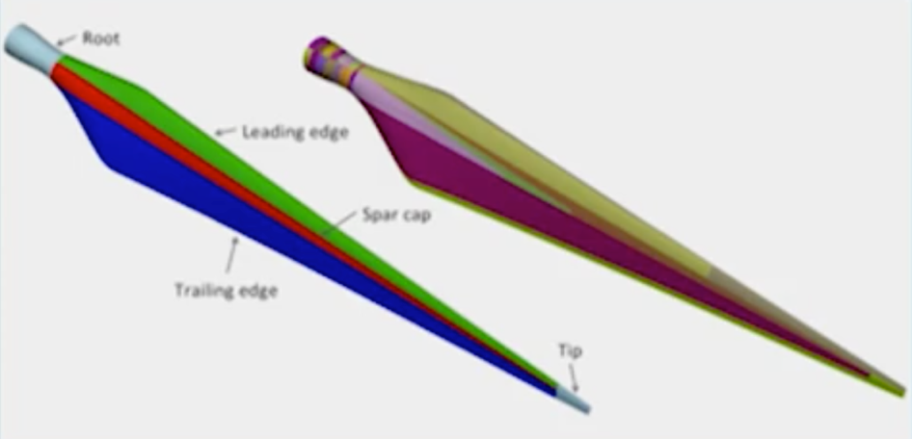*What materials are the wind turbines made out of?*

Most turbines are constructed out of fiberglass epoxy with some carbon fiber included. The construction of a turbine is meant to be as light as possible with enough strength/stiffness in the *spar cap* to resist bending as the wind force is applied to the turbine.

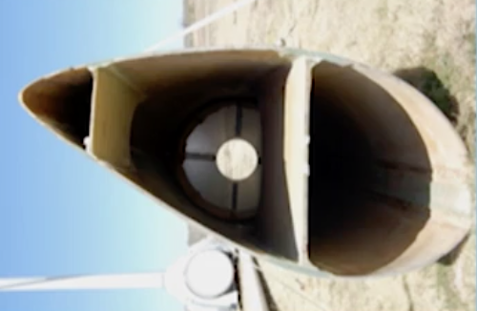

The interior of a turbine includes *sheer webs* (the perpendicular pieces connecting the pressure and suction sides of the air foils used to resist torsion/twisting which would alter the aerodynamics (and therefore potential electrical generation).

The reason why there are three blades on a turbine is because with one or two blades, the weight distribution of the rotating blades cause different loads on the tower at different points in the blade’s rotation. This weight distribution gets evened out at three blades. Additionally, the efficiency gains of adding a fourth or fifth blade doesn’t sufficiently offset the cost of adding them into the structure.

The bigger the turbine, the more power that turbine is able to capture from the wind. This is because there’s more surface area from which to capture the power in the wind. However, once you’re working with larger turbines, structurally you need to build it to withstand the loads not only from the wind bbut also from the turbine’s own weight.

The other challenges related to large turbines is in manufacturing and transportation. On the manufacturing side, you need to figure out how to build the turbine – e.g., breaking it up into multiple pieces versus one structure. Once you’ve figured out the manufacturing part, you then need to figure out how to transport the different pieces to where they need to go in order to capture the wind power. Before further exploring how to scale larger turbines (100-120m is the max length today), more exploration is needed to determine how long the turbines will last and how long they will generate power.

*What’s next for wind power*

In regards to being able to meet the goal of 25% of electricity generated by wind, the most interesting developments on the engineering side are related to offshore technologies, both bottom-fixed and floating. Offshore, the same wind speeds exist at much shorter heights, so the tower can be much shorter.

However, there’s a greater engineering challenge to connect to the grid onshore. Additionally, with floating designs, getting the turbine standing and operational is difficult unless you have a very calm body of water. In places like Norway that have plentiful fjords with deep sea bottoms, this isn’t as big of an issue as it is in North America where the locales to put the floating turbines are choppier. For fixed bottom turbines, the hydrodynamics at the base of a turbine tends to erode the base so that is another challenge.